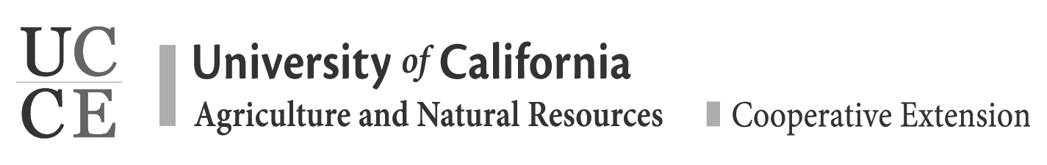
Chaperone Agreement Form
Overview:
As a chaperone for the 4-H Snow Camp, I will provide a healthy and positive environment for all members of our delegation and serve as a representative and partner of the University of California 4-H State Office.
General Agreements & Expectations: As a volunteer for this regional sponsored 4-H event:
• I understand that my participation in this volunteer venture is of my own choosing and I will enthusiastically support and uphold the policies and procedures as set forth in the California 4-H Policy manual
• I agree to abide by the California 4-H Adult Volunteer Code of Conduct http://4h.ucanr.edu/files/16404.pdf
• Chaperones should support the efforts of group actives presenters to maintain positive behavior during sessions
• Chaperones are expected to assist and/or provide correction for any and all youth if the situation is such that the member or another person is in immediate danger of harm—either physically or emotionally. If the situation is not immediately harmful and does need discussion, please refer the incident to the Trip Coordinator
• Chaperones may not deviate from the established itinerary and assigned group
• I agree to fulfill all the expectations as outlined in the Volunteer Position Description for 4-H Snow Camp
• I agree that fulfilling this responsibility must come before personal preferences or needs.
• I agree to attend all mandatory meetings set by the 4-H Snow Camp for the duration of my volunteer relationship. These meetings will be scheduled on an as needed basis
• Chaperones need to know where the youth under your supervision are at all times. To aid you in this responsibility, you will be given a list of your 4-H members, their room number and cell phone number
• Parents or 4-H members relatives who are not chaperones or participants in the 4-H snow camp trip will not be permitted to interfere with the chaperones responsibilities, nor substitute, unless approved by the 4-H snow camp coordinator If a problem arises that is serious enough in nature to warrant my removal as chaperone of the 4-H Snow Camp, I understand that I will not be refunded and will be responsible to bear any additional costs to return home
NOTE: This removal decision will be made by the accompanying professional staff member(s) after provided the opportunity to respond to any allegations. The chaperone may also be subjected to disciplinary action upon return home.

__________________________________________________________ _________________
Chaperone Signature Date

